**WEEK 7**

**Superset ID: 6426263**

**9.REACT JS-HOL**

**src/components**

**List.js**

import React from 'react';

const List = () => {

  const players = [

    { name: 'Virat', score: 85 },

    { name: 'Rohit', score: 95 },

    { name: 'Dhoni', score: 60 },

    { name: 'Bumrah', score: 75 },

    { name: 'Ashwin', score: 50 },

    { name: 'Shami', score: 78 },

    { name: 'Rahul', score: 90 },

    { name: 'Pant', score: 40 },

    { name: 'Hardik', score: 80 },

    { name: 'Gill', score: 88 },

    { name: 'Siraj', score: 65 },

  ];

  const filteredPlayers = players.filter(*player* => *player*.score < 70);

  return (

    <div>

      <h2>All Players</h2>

      <ul>

        {players.map((*p*, *idx*) => (

          <li *key*={*idx*}>{*p*.name} - {*p*.score}</li>

        ))}

      </ul>

      <h2>Players with score below 70</h2>

      <ul>

        {filteredPlayers.map((*p*, *idx*) => (

          <li *key*={*idx*}>{*p*.name} - {*p*.score}</li>

        ))}

      </ul>

    </div>

  );

};

export default List;

**Indian.js**

import React from 'react';

const Indian = () => {

  const oddTeam = ['Virat', 'Dhoni', 'Ashwin', 'Rahul', 'Hardik'];

  const evenTeam = ['Rohit', 'Bumrah', 'Shami', 'Gill', 'Siraj'];

  const [p1, p2, p3, ...others] = oddTeam;

  const T20players = ['Rohit', 'Gill', 'Pant'];

  const RanjiTrophy = ['Pujara', 'Karun', 'Saha'];

  const mergedPlayers = [...T20players, ...RanjiTrophy];

  return (

    <div>

      <h2>Odd Team Players</h2>

      <ul>

        {oddTeam.map((*player*, *idx*) => (

          <li *key*={*idx*}>{*player*}</li>

        ))}

      </ul>

      <h2>Even Team Players</h2>

      <ul>

        {evenTeam.map((*player*, *idx*) => (

          <li *key*={*idx*}>{*player*}</li>

        ))}

      </ul>

      <h2>Merged Players (T20 + Ranji)</h2>

      <ul>

        {mergedPlayers.map((*player*, *idx*) => (

          <li *key*={*idx*}>{*player*}</li>

        ))}

      </ul>

    </div>

  );

};

export default Indian;

**App.js**

import React from 'react';

import List from './components/List';

import Indian from './components/Indian';

function App() {

  const flag = true;

  return (

    <div *className*="App">

      <h1>Cricket App</h1>

      {flag ? <List /> : <Indian />}

    </div>

  );

}

export default App;

**OUTPUT**

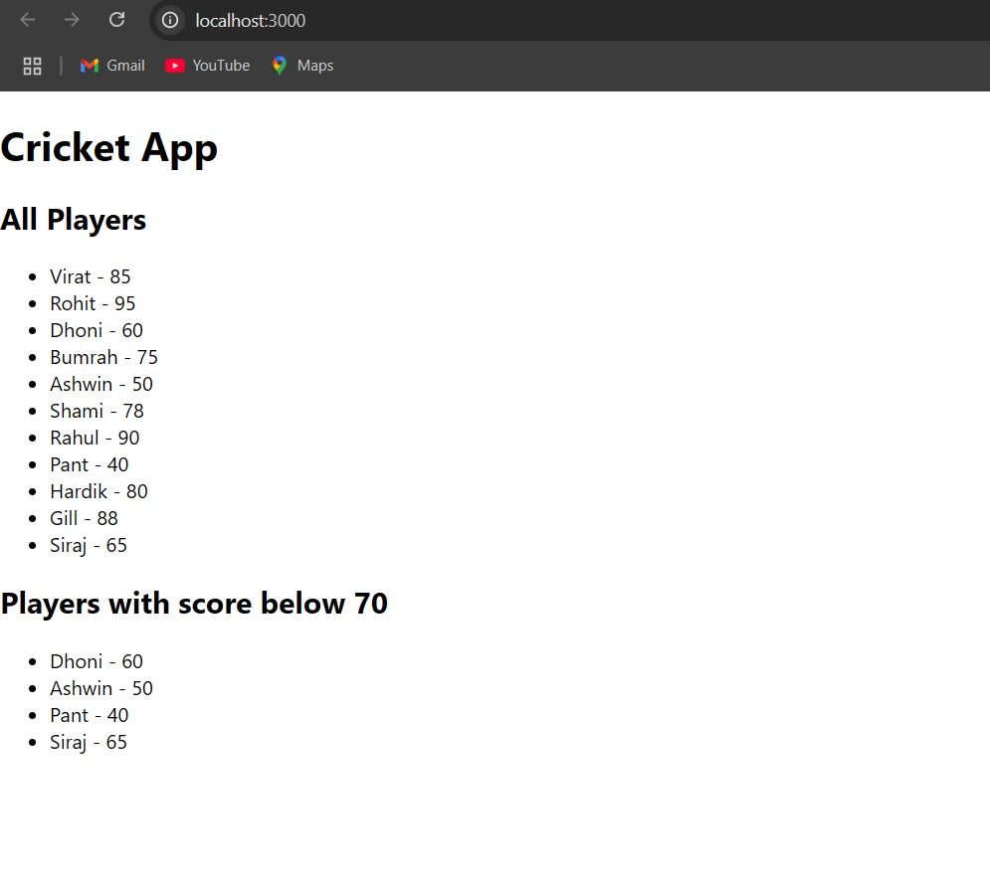

**10.REACT JS-HOL**

**src/App.js**

import React from 'react';

function App() {

  const heading = <h1>Office Space Rental Listings</h1>;

  const officeImage = "https://t4.ftcdn.net/jpg/03/84/55/29/360_F_384552930_zPoe9zgmCF7qgt8fqSedcyJ6C6Ye3dFs.jpg";

  const officeDetails = {

    name: "Skyline Tower",

    rent: 75000,

    address: "123 Business Street, Mumbai"

  };

  const officeList = [

    { name: "Skyline Tower", rent: 75000, address: "123 Business Street, Mumbai" },

    { name: "Eco Space", rent: 58000, address: "56 Eco Drive, Bangalore" },

    { name: "Tech Park", rent: 90000, address: "88 Tech Park, Hyderabad" },

    { name: "Startup Hub", rent: 40000, address: "44 Startup Lane, Chennai" },

  ];

  return (

    <div *style*={{ padding: '20px', fontFamily: 'Arial, sans-serif' }}>

      {heading}

      <img *src*={officeImage} *alt*="Office Space" *style*={{ width: '500px', height: '300px', borderRadius: '8px' }} />

      <h2>Featured Office</h2>

      <div *style*={{ border: '1px solid #ccc', padding: '15px', marginBottom: '20px' }}>

        <p><strong>Name:</strong> {officeDetails.name}</p>

        <p>

          <strong>Rent:</strong>{" "}

          <span *style*={{ color: officeDetails.rent < 60000 ? 'red' : 'green' }}>

            ₹{officeDetails.rent}

          </span>

        </p>

        <p><strong>Address:</strong> {officeDetails.address}</p>

      </div>

      <h2>All Office Listings</h2>

      {officeList.map((*office*, *index*) => (

        <div *key*={*index*} *style*={{ border: '1px solid #ddd', padding: '10px', marginBottom: '10px', borderRadius: '6px' }}>

          <p><strong>Name:</strong> {*office*.name}</p>

          <p>

            <strong>Rent:</strong>{" "}

            <span *style*={{ color: *office*.rent < 60000 ? 'red' : 'green' }}>

              ₹{*office*.rent}

            </span>

          </p>

          <p><strong>Address:</strong> {*office*.address}</p>

        </div>

      ))}

    </div>

  );

}

export default App;

**OUTPUT:**

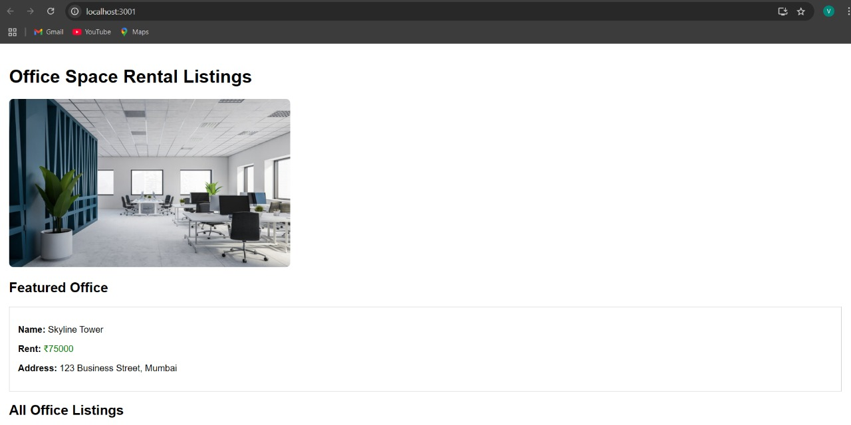

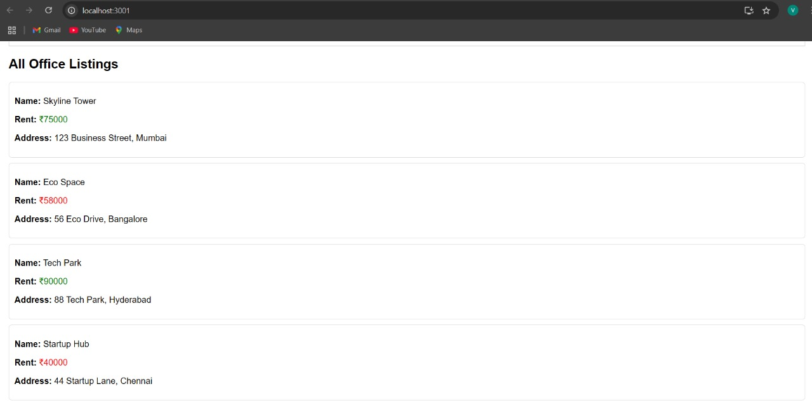

**11.REACT JS-HOL**

**src/components**

**CurrencyConvertor.js**

import React, { Component } from 'react';

class CurrencyConvertor extends Component {

  constructor(*props*) {

*super*(*props*);

    this.state = {

      rupees: '',

      euro: ''

    };

  }

  handleChange = (*e*) => {

    this.setState({ rupees: *e*.target.value });

  }

  handleSubmit = (*e*) => {

*e*.preventDefault();

    const rupees = parseFloat(this.state.rupees);

    const euroRate = 0.011;

    if (!isNaN(rupees)) {

      const euro = (rupees * euroRate).toFixed(2);

      this.setState({ euro });

    }

  }

  render() {

    return (

      <div *style*={{ marginTop: '20px' }}>

        <h2>Currency Convertor (INR → EUR)</h2>

        <form *onSubmit*={this.handleSubmit}>

          <label>

            Enter INR:

            <input

*type*="number"

*value*={this.state.rupees}

*onChange*={this.handleChange}

*style*={{ marginLeft: '10px' }}

            />

          </label>

          <button *type*="submit" *style*={{ marginLeft: '10px' }}>Convert</button>

        </form>

        {this.state.euro && (

          <p *style*={{ marginTop: '10px' }}>

            Converted Amount in Euro: <strong>€{this.state.euro}</strong>

          </p>

        )}

      </div>

    );

  }

}

export default CurrencyConvertor;

**index.css**

* {

  margin: 0;

  padding: 0;

  box-sizing: border-box;

}

html, body {

  height: 100%;

  width: 100%;

  font-family: 'Segoe UI', Tahoma, Geneva, Verdana, sans-serif;

  background-color: #f9f9f9;

  color: #333;

}

button {

  background-color: #3498db;

  color: white;

  border: none;

  padding: 8px 16px;

  margin: 5px;

  border-radius: 5px;

  cursor: pointer;

  transition: background-color 0.2s ease-in-out;

}

button:hover {

  background-color: #2980b9;

}

input[type="number"], input[type="text"] {

  padding: 8px;

  border: 1px solid #ccc;

  border-radius: 4px;

  margin-left: 10px;

}

form {

  margin-top: 15px;

}

h1, h2 {

  margin-bottom: 15px;

  color: #2c3e50;

}

hr {

  margin: 25px 0;

  border: none;

  border-top: 1px solid #ddd;

}

#root {

  display: flex;

  flex-direction: column;

  align-items: center;

  padding: 20px;

}

**App.js**

import React, { Component } from 'react';

import CurrencyConvertor from './components/CurrencyConvertor';

class App extends Component {

  constructor(*props*) {

*super*(*props*);

    this.state = {

      counter: 0

    };

    this.increment = this.increment.bind(this);

    this.sayHello = this.sayHello.bind(this);

  }

  increment() {

    this.setState(*prevState* => ({

      counter: *prevState*.counter + 1

    }));

    this.sayHello(); *// Multiple methods*

  }

  decrement = () => {

    this.setState(*prevState* => ({

      counter: *prevState*.counter - 1

    }));

  }

  sayHello() {

    console.log("Hello! This is a static message.");

  }

  sayWelcome = (*msg*) => {

    alert(`Message: ${*msg*}`);

  }

  handleClick = (*event*) => {

    alert("I was clicked (Synthetic Event)!");

    console.log(*event*); *// Synthetic event object*

  }

  render() {

    return (

      <div *style*={{ padding: '20px', fontFamily: 'Arial' }}>

        <h1>React Event Handling Examples</h1>

        <h2>Counter: {this.state.counter}</h2>

        <button *onClick*={this.increment}>Increase</button>{" "}

        <button *onClick*={this.decrement}>Decrease</button>

        <hr />

        <button *onClick*={() => this.sayWelcome("Welcome to React!")}>Say Welcome</button>

        <hr />

        <button *onClick*={this.handleClick}>Click Me (Synthetic Event)</button>

        <hr />

        <CurrencyConvertor />

      </div>

    );

  }

}

export default App;

**OUTPUT:**

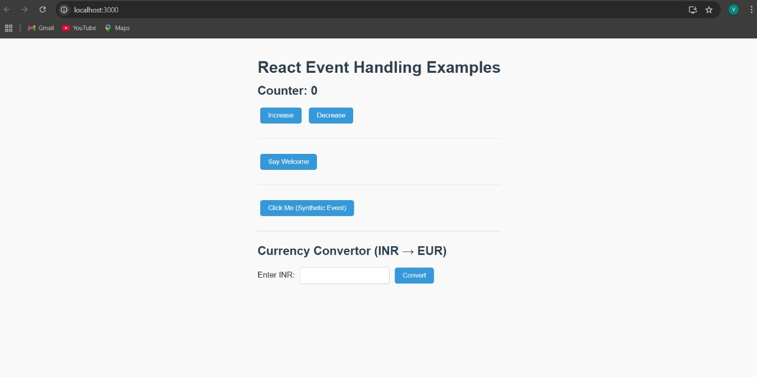

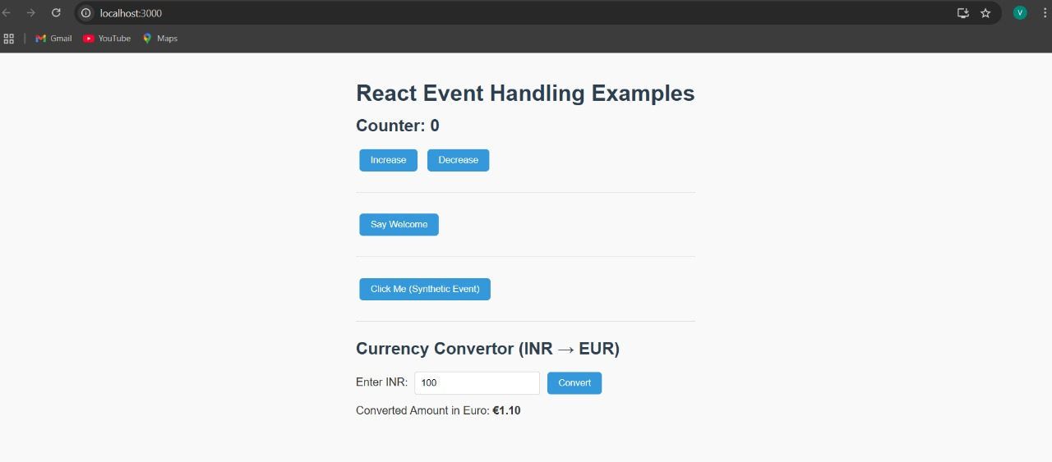

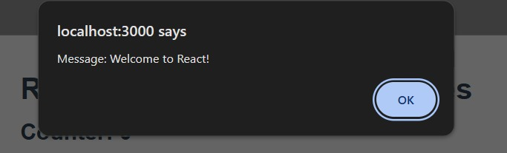

**12.REACT JS-HOL**

**App.js**

import React, { Component } from 'react';

class App extends Component {

  constructor(*props*) {

*super*(*props*);

    this.state = {

      isLoggedIn: false

    };

  }

  handleLogin = () => {

    this.setState({ isLoggedIn: true });

  }

  handleLogout = () => {

    this.setState({ isLoggedIn: false });

  }

  render() {

    let pageContent;

    let button;

    if (this.state.isLoggedIn) {

      pageContent = (

        <div>

          <h2>Welcome, User!</h2>

          <p>You can now book your flight tickets.</p>

          <ul>

            <li>Flight: AI 202 | From: Mumbai | To: Delhi | Price: ₹5500</li>

            <li>Flight: SG 408 | From: Bangalore | To: Hyderabad | Price: ₹4200</li>

          </ul>

        </div>

      );

      button = <button *onClick*={this.handleLogout}>Logout</button>;

    } else {

      pageContent = (

        <div>

          <h2>Welcome, Guest</h2>

          <p>Please log in to book tickets.</p>

          <ul>

            <li>Flight: AI 202 | From: Mumbai | To: Delhi</li>

            <li>Flight: SG 408 | From: Bangalore | To: Hyderabad</li>

          </ul>

        </div>

      );

      button = <button *onClick*={this.handleLogin}>Login</button>;

    }

    return (

      <div *style*={{ fontFamily: 'Arial, sans-serif', padding: '20px' }}>

        <h1>Flight Ticket Booking App</h1>

        {pageContent}

        <div *style*={{ marginTop: '20px' }}>

          {button}

        </div>

      </div>

    );

  }

}

export default App;

**index.css**

body {

  background-color: #f0f2f5;

  color: #333;

  font-family: 'Segoe UI', sans-serif;

}

button {

  padding: 10px 20px;

  font-size: 1rem;

  background-color: #3498db;

  color: white;

  border: none;

  border-radius: 6px;

  cursor: pointer;

}

button:hover {

  background-color: #2980b9;

}

**OUTPUT:**

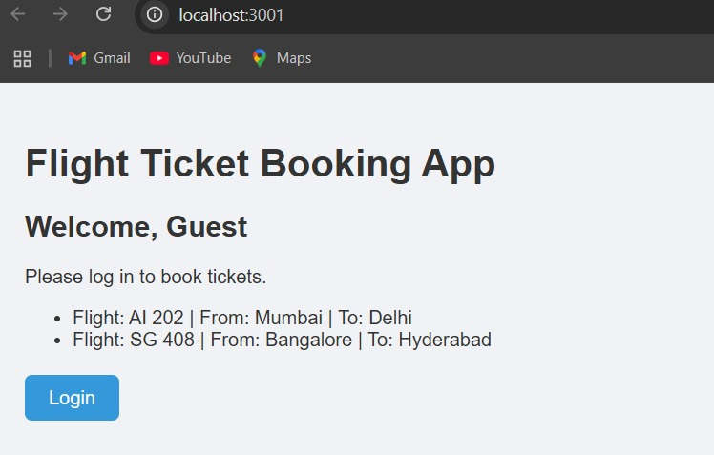

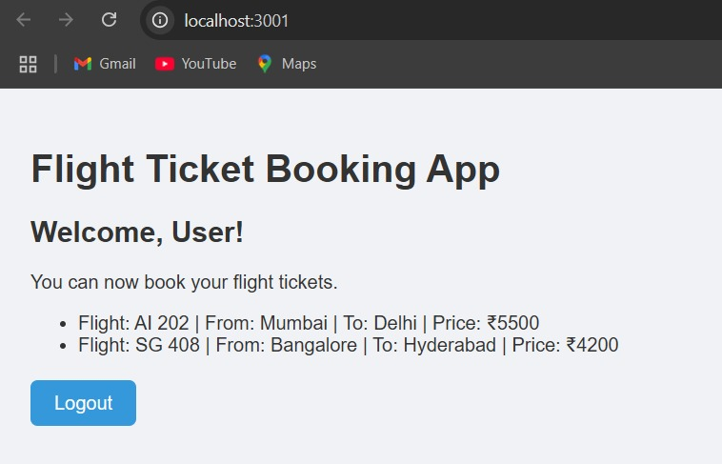

**13.REACT JS-HOL**

**src/components**

**BookDetails.js**

import React from 'react';

import '../App.css';

const BookDetails = () => {

  const books = [

    { id: 1, title: "React Essentials", author: "Dan Abramov" },

    { id: 2, title: "JavaScript Deep Dive", author: "Kyle Simpson" },

    { id: 3, title: "Modern Web Development", author: "Sarah Drasner" },

  ];

  return (

    <div>

      <h2>📚 Book List</h2>

      <ul>

        {books.map(*book* => (

          <li *key*={*book*.id}>

            <strong>{*book*.title}</strong> by {*book*.author}

          </li>

        ))}

      </ul>

    </div>

  );

};

export default BookDetails;

**BlogDetails.js**

import React from 'react';

import '../App.css';

const BlogDetails = ({ *isLoggedIn* }) => {

  return (

    <div>

      <h2>📝 Blog Details</h2>

      {

*isLoggedIn*

          ? <p>Welcome back! You can read and write blogs.</p>

          : <p>Please log in to view blogs.</p>

      }

    </div>

  );

};

export default BlogDetails;

**CourseDetails.js**

import React from 'react';

import '../App.css';

const CourseDetails = ({ *show* }) => {

  if (!*show*) return null;

  const courses = ["React Basics", "Advanced JS", "UI/UX Design"];

  return (

    <div>

      <h2>🎓 Course List</h2>

      <ul>

        {courses.map((*course*, *index*) => (

          <li *key*={*index*}>{*course*}</li>

        ))}

      </ul>

    </div>

  );

};

export default CourseDetails;

**App.css**

.container {

  background-color: #ffffff;

  border-radius: 10px;

  box-shadow: 0px 4px 8px rgba(0, 0, 0, 0.05);

  padding: 20px;

  margin-bottom: 25px;

  max-width: 600px;

  margin-left: auto;

  margin-right: auto;

}

.container h2 {

  color: #2c3e50;

  border-bottom: 2px solid #e2e2e2;

  padding-bottom: 8px;

  margin-bottom: 15px;

}

ul {

  list-style-type: none;

  padding-left: 0;

}

li {

  background-color: #f8f9fa;

  margin: 8px 0;

  padding: 10px 15px;

  border-left: 5px solid #3498db;

  border-radius: 5px;

  transition: background-color 0.3s ease;

}

li:hover {

  background-color: #eaf4fc;

}

**App.js**

import React, { useState } from 'react';

import BookDetails from './components/BookDetails';

import BlogDetails from './components/BlogDetails';

import CourseDetails from './components/CourseDetails';

function App() {

  const [isLoggedIn, setIsLoggedIn] = useState(false);

  const [showCourses, setShowCourses] = useState(true);

  const toggleLogin = () => setIsLoggedIn(!isLoggedIn);

  const toggleCourses = () => setShowCourses(!showCourses);

  let loginMessage;

  if (isLoggedIn) {

    loginMessage = <p *style*={{ color: "green" }}>You are logged in ✅</p>;

  } else {

    loginMessage = <p *style*={{ color: "red" }}>You are not logged in ❌</p>;

  }

  return (

    <div *style*={{ padding: '20px', fontFamily: 'Arial' }}>

      <h1>🧑‍💻 Blogger App</h1>

      {loginMessage}

      <button *onClick*={toggleLogin} *style*={{ marginRight: '10px' }}>

        {isLoggedIn ? "Logout" : "Login"}

      </button>

      <button *onClick*={toggleCourses}>

        {showCourses ? "Hide Courses" : "Show Courses"}

      </button>

      <hr />

      {*}*

      <BookDetails />

      {}

      <BlogDetails *isLoggedIn*={isLoggedIn} />

      {}

      <CourseDetails *show*={showCourses} />

    </div>

  );

}

export default App;

**index.css**

body {

  font-family: 'Segoe UI', sans-serif;

  background: #f8f9fa;

  color: #333;

}

h1, h2 {

  color: #2c3e50;

}

button {

  background: #3498db;

  color: white;

  padding: 8px 14px;

  border: none;

  border-radius: 5px;

  cursor: pointer;

}

button:hover {

  background: #2980b9;

}

ul {

  list-style-type: square;

  margin-top: 10px;

}

**OUTPUT:**

